Suffering with Mouth Ulcers?
Recurrent Aphthous ulcers is the technical name given to a common form of ulcers seen in any part of the mouth including the tongue, cheek and lips. They typically start in childhood or adolescence and are characterised as round or oval with a yellow granular base and a red ring border. They reoccur every few weeks and can vary in size from a crop of tiny pinpoint to a few minor or larger (major) which can measure anything up to 1-3cm. Although they can vary in size they have one thing very much in common which is: they are extremely painful and can make simple tasks such as teeth cleaning, eating, drinking almost impossible!. Major ulcers have been known to last anything up to 4weeks and can scar the tissues.
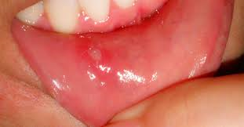
Minor Apthous ulcer
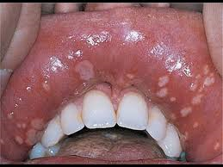
Herpetiform combined with minor
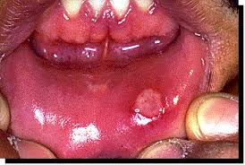
Major

Causes
It is not fully understood what causes these group of ulcers as everyone will experience the extent differently, there is not one main cause but a strong association has been made with the following:
- Anaemia in any form such as iron deficiency, B12 folate.
- Vitamin deficiency
- Gastro intestinal disease such as Crohns disease or Ulcerative Collitis
- Stress
- Allergy to certain food such as tomatoes, nuts, fruit
- Allergy to Sodium Lauryl Sulphate which is a foaming agent placed in toothpastes- PROENAMEL by Sensodyne is the only renowned toothpaste which DOES NOT contain SLS
- Trauma

Recommended treatment
- Elimination of causative factor, identifying trigger foods and removing from the diet
- Eliminating SLS, switching toothpaste to Pro enamel
- Maintaining excellent oral hygiene routine as high plaque levels exacerbate the symptoms and delay healing
- Alcohol free based mouth wash to stimulate a sterile environment for healing
- Use of a local anaesthetic based mouth wash such as Benzydamine (Difflam) when symptoms severe
- Steroid based medicament prescribed by your dentist

Please note if you have an ulcer which has been present for 2 weeks or more and is not healing, please visit your dentist for advice

